Learning Session#2:

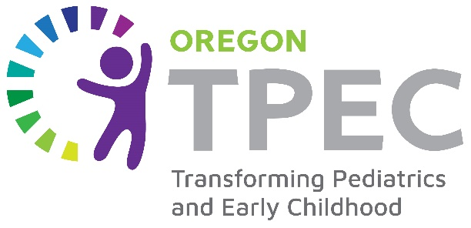
Addressing the Social Emotional Needs of Young Children:
Early Identification, Assessments, Brief Interventions, and Pathways to Additional Supports
November 2nd, 2023 8 AM-12 PM

Hidden Creek Community Center
5100 NE Hidden Creek Dr, Hillsboro, OR 97124
11/2/23 Meeting Agenda:
Door open at 7:30am for breakfast.
- Welcome and Review of the Agenda & Goals for the Meeting
- Celebrating Achievements from Last Six Months
- Small Group Ice Breaker (Assigned tables by role, not by practice site)
- Review of the Continuum of Addressing the Social Emotional Needs of Young Children & Focus for Today’s Learning Sessions: Assessments, Brief Interventions, and Pathways to Additional Supports and Practice-Level Data Snapshot on Social-Emotional Services
- What is Social-Emotional Health for Young Children?
  - Definition and domains
  - Impact and ecology of social emotional delays
  - Long-term outcomes
Breaking it Into Parts: Providing Tools and Strategies to Support Implementation
- Part 1: Identifying Children at Risk for Social-Emotional Delays
- Part 2: Assessment of Children Identified at Risk for Social-Emotional Delays
  - Hearing from Hillsboro Pediatrics on Their Screening Journey
BREAK
- Part 3: Brief Interventions
  - Hearing from Metropolitan Pediatrics on Their Learnings to Date from Triple P
- Part 4: Pathways to Additional Supports
- Small Group Action Plan Session: Planning Your Priorities for the Next Six Months (By Site, Facilitated by OPIP)
- Close Out & Next Steps
Participants complete evaluation survey and receive a boxed lunch.

Participants can stay from 12-12:30 and eat lunch with TPEC peers if you would like to hear about other sites’ Action Plan strategies (optional).

The Transforming Pediatrics for Early Childhood (TPEC) project is supported by the Health Resources and Services Administration (HRSA) of the U.S. Department of Health and Human Services (HHS) as part of an award totaling $3,991,229.00 with zero percentage financed with non-governmental sources. The contents are those of the author(s) and do not necessarily represent the official views of, nor an endorsement, by HRSA, HHS, or the U.S. Government. For more information, please visit HRSA.gov.

